**What are the different types of traces in SAP ?**

* SQL Trace (Trace for SQL statements)
* Enqueue Trace (Trace for enqueue/lock requests, waiting etc)
* RFC Trace
* Table Buffer Trace

**How to activate a Trace for a user in SAP system ?**

Goto transaction ST05  and you will get the below screen :

[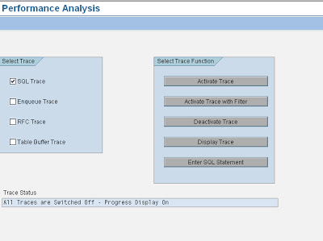](https://4.bp.blogspot.com/-TMFDt4Hz2rE/TgDXcUNaqUI/AAAAAAAAAEg/ywkXOolAIm4/s1600/trace1.bmp)

Select the type of trace you would like to activate and press activate trace to start tracing.

Please find below functionality of various functions in the above screenshot :

**Activate Trace :** This is used to activate the trace for the same user who is starting the trace

[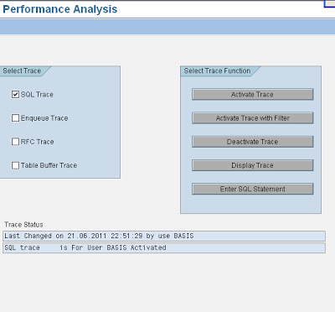](https://2.bp.blogspot.com/-lL1kdmsgFvY/TgDXfw_0AII/AAAAAAAAAEk/lFJiBxPv6lA/s1600/trace2.bmp)

**Activate Trace with Filter :**  This functionality is used to trace the activity of a different user(other than the user who is starting the trace) and filter can be done to trace a  specific transaction or program.

[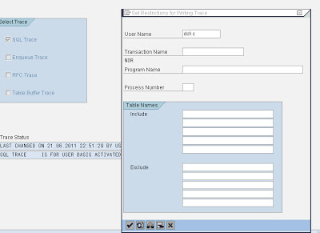](https://3.bp.blogspot.com/-rQiFTxBY_UA/TgDXg3RvrCI/AAAAAAAAAEo/uPHpcsF14h8/s1600/trace3.bmp)

**Deactivate Trace :** This functionality is used to deactivate the trace

[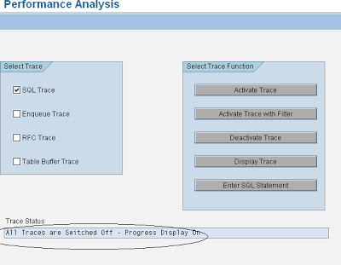](https://2.bp.blogspot.com/-2kJriOn9JJs/TgDaniz5njI/AAAAAAAAAFA/fPkWJ1jkfIg/s1600/trace9.bmp)

**Display Trace :**   This functionality is used to display trace

[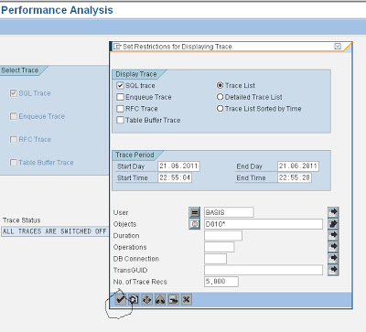](https://4.bp.blogspot.com/-uB4MtLnDQAU/TgDXmZN1UiI/AAAAAAAAAEs/ugG3umpplmg/s1600/trace4.bmp)

Click on tick mark to display the trace

[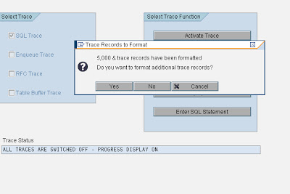](https://3.bp.blogspot.com/-XqiuiFW_9LU/TgDXnccIIjI/AAAAAAAAAEw/NEwxyvNEFiE/s1600/trace5.bmp)

Click on Yes to display the trace as below:

[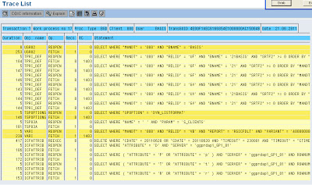](https://1.bp.blogspot.com/-qepdL91GKHA/TgDXo2Md3iI/AAAAAAAAAE0/3701kxBh3hs/s1600/trace6.bmp)

**Enter SQL Statement :** This functionality is used to analyse an SQL statement

Click on this pushbutton to view the below screen :

[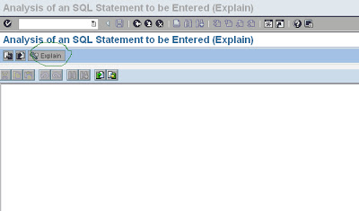](https://1.bp.blogspot.com/-yBzQJHOnhcY/TgDXqFgumDI/AAAAAAAAAE4/7_h94KZOth0/s1600/trace7.bmp)

**Trace Status :** This area is used to inform about the status of the trace at that point of time like traces activated, deactivated etc

[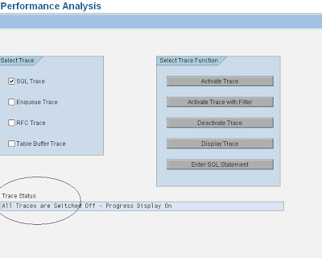](https://1.bp.blogspot.com/-ZysprictTOs/TgDXq7cybdI/AAAAAAAAAE8/gAWV2bcp9DU/s1600/trace8.bmp)

**Guidelines for activating a Performance trace**

1. If you are tracing a particular activity of a user, please make sure that the particular user is not performing any other activity in the system. Otherwise trace file will be difficult to analyze. For reasons of simplicity, please request user to perform only one activity while the trace is activated.

1. Please make sure that no background jobs or update processes are running in that SAP for  that particular user whose activity is being traced. Otherwise trace won’t be clear
2. By default, SQL trace is selected in ST05 transaction. Incase you would like to trace others( like RFC trace, buffer trace)  please activate them also.
3. Normally we are interested in the buffer load processes that get recorded while tracing an activity through SQL trace. Therefore, it is suggested to execute the program or activity that is to be traced once before actually tracing it so that all the buffer loads processes will happen. In the next run, since buffers were already loaded SQL trace doesn’t capture un-necessary details related to buffer load which makes it easy to analyze the trace.
4. In cases of distributed SAP system, where there are number of application servers  then you need to activate the trace in the particular application server where the user is performing the activity. In other words, trace won’t get recorded if you activate trace in one application server and user is performing the activity in another application server.
5. If you would like to record a trace for background job or for an update request in a distributed SAP system, it is suggested to activate the trace in all the application servers that are present in the SAP system. This is required because you will never know to which application server the particular request goes for execution.

If you are tracing an activity of any other user you can look at following monitors during the trace :

* Workprocesses overview (SM50/SM66)
* Operating system monitor of Database server to identity any CPU bottlenecks in database server)
* Database process monitor for monitoring the execution of SQL statements

**Profile parameter settings for Performance Trace (ST05):**

Please note that trace cannot be taken for very long duration as the size of the trace file is limited as set by SAP profile parameter. When the trace file is full, the oldest entries are deleted or overwritten by the newest entries i.e. writing to the trace file is cyclical.

The SAP profile parameter rstr/max_diskspace is used to set the size of the trace file in a SAP system. The default trace file size is 16MB

For a trace file, default file name also can be set using the SAP profile parameter rstr/file.

**Trace files and their significance:**

Trace files contain important technical information which will be required by basis consultant to troubleshoot  in event of problems / issues with the SAP system.

**Different levels of traces:**

There are 4 trace levels in SAP.

Level 0  - No trace

Level 1 – Write error messages in the trace file

Level 2 – Full trace ; The trace entries are being written will vary with the SAP program that is being traced

Level 3 – It is similar to Level 2 but in addition to that it also traces data blocks

SAP profile parameter **rdisp/TRACE** is used to set the developer trace level in SAP.

**Trace level 1 is the “default” trace level set in an SAP system**.

Sometimes there may be a requirement to developers or even basis guys to increase trace level from the default value 1 so that much detailed trace can be captured which helps in resolution of an issue.

To change this parameter, goto RZ11 transaction and provide rdisp/TRACE as shown below:

[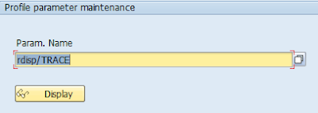](https://3.bp.blogspot.com/-DzW3sbajGSE/T-H1ejHxYEI/AAAAAAAAAh0/Z0tl7XFUz08/s1600/Capture2.PNG)

Please click on “Display” button to view the below screen.

[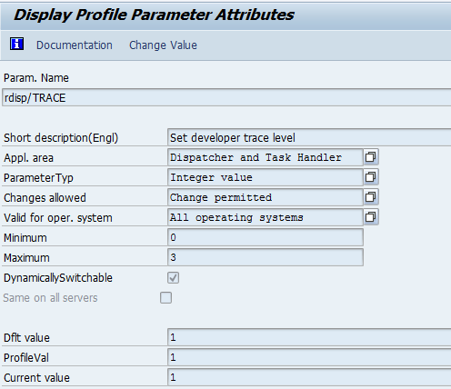](https://3.bp.blogspot.com/-ur-MzS8YtG0/T-H1yDt8kwI/AAAAAAAAAh8/0dALAhMKk3E/s1600/Capture3.PNG)

As seen from the above screen, this is a “dynamically switchable” parameter which means that trace level can be changed immediately and it doesn’t need restart of an SAP system for the parameter value to take effect.

If your SAP system contains more application servers, please tick “Same on all servers” checkbox in the above screen so that trace level can be changed dynamically across all the application servers. If you would like to change in a particular application server, it is not required to tick this check box.

In the above screen, default value , profile value and current value are set to 1. In case, it is required to set trace level for temporary period(till restart of the application server), it can be set by modifying current value accordingly. Please note that after restart of the server, the current value will be lost and system will start using the profile parameter that is set for that instance.

To set this parameter value permanently, you need to set this value in RZ10 profile parameter in all the application servers that is required. Once SAP system is restarted, it will read the profile values and come up with the value that is set to this parameter.

**Advantages /Disadvantages in setting high trace levels in SAP**

While higher trace levels provide much more detailed trace which helps in troubleshooting the issue there are some disadvantages as well.

Trace level 2 or higher influences the system performance and should only be set for error analysis. In addition, trace files grow very rapidly  when trace is activated. We should ensure that enough space is left on the disk on which the SAP directory is located. Using parameter %rdisp/TRACE_LOGGING%, we can ensure the trace files do not grow to an arbitrary size when trace is active.

Trace logging can be activated by setting the parameter rdisp/TRACE_LOGGING to ON. Also specify the size at which once reached, the trace file is logged and the trace level is reset to 1.

Please find below values that can be set to this parameter and their significance

rdisp/TRACE_LOGGING = off :  no tracing

rdisp/TRACE_LOGGING = on, 1000 : trace is logged if the trace file contains more than 1000 bytes

rdisp/TRACE_LOGGING = on, 20k : trace is logged if the trace file contains more than 20KB

rdisp/TRACE_LOGGING = on, 30m , global =on activates trace logging, if the trace file is larger than 30mega bytes. If the pattern searched for has been found in a trace file, trace logging is deactivated on all the servers.

Parameter rdisp/TRACE_PATTERN_0 is used to specify a trace pattern for automatically switching off the SAP trace. This parameter has effect only if trace logging is activated using rdisp/TRACE_LOGGING. In this scenario, trace files are searched for the search pattern. If pattern is found, trace logging is deactivated and trace level is reset to 1.

In this way, setting these parameters avoid trace files to grow to arbitrary size and  limits the trace logging based on the size of file specified.